Chapter I

The discrepancy towards Indonesia’s literacy rates in alternative media against official statistics has always remained constant. According to Badan Pusat Statistik, 2024, only 14 provinces were able to provide data samples out of 34 that had established public libraries. These libraries operated from secondhanded book donations, non-updated research papers, and old archives. In this data, an average Indonesian only borrowed 2 literacy media per year. This explained why Indonesia ranked in the lower margin of the triennial Programme for International Student Assessment (PISA) for the past three examinations (2015, 2018 and 2022; one-year delay due to the Covid-19 pandemic). The tests have been conducted using the PISA Reading Scale, with gradual metrics ranging from Level 1 (Subdivided Baseline) where students showed abilities in classifying simple information from a text, to Level 6 (Highest) where they comprehended more elaborate matters and evaluated misinformation.

Yet, as stated above, the frank interest towards literacy is undercover. Seasonal reading festivals and book party events, like Semesta Buku by Gramedia in 2026 and Big Bad Wolf in 2025, have managed to attract 46% more customers than normal (Gramedia, 2026). The success is followed by selling 5 millions copies of newly published books (Big Bad Wolf, 2025). Its stock supply comprises a factor that has not been covered by official statistics, which is resource accessibility. Subsequently, a circulation of all-time favorites is procured. This disproves the idea of how most Indonesian people are illiterate. However, it is still pivotal to determine literacy skills, instead of viewing official statistics as misinformation.

In this matter, the current literacy trend is engrossed by digitalized service, using online platforms as it provides hands-on search engines, user algorithms and personalization (Pramesti, 2026). This opens layers of discussions about: 1) The new challenges that arise in regards to media literacy in online platforms and 2) How appropriate conducts resurface as media literacy is integrated on the internet.

In a research conducted by George & Baskar, 2025, a significant incertitude on both points is the use of Artificial Intelligence (AI) in many media literacy platforms. Systematically, AI works by patterned metafunction that allows it to glean data-based components from search engines. Its core principles of Machine Learning and Natural Language Processor transcend the cloud computing circuits without coercing “common sense” in the AI itself (Palenski et al., 2024). From here, media literacy has retained another composite variable, which is information. This puts a perspective on how users engage with Media and Information Literacy (MIL), a framework designated and renewed by UNESCO in 2024, ahead of the status quo. However, it is predictable that ethical browsing and intellectual property rights turn questionable within this system (Stiglitz, 2025).

AI has arguably put human-made arts (mainly digital forms but not exclusive to that) and generated modifications into seizure. Replication prompts towards certain styles has eradicated distinctions between the two, given the example of Hayao Miyazaki’s copyright violation in his disseminated Studio Ghibli-styled artworks in 2025. From that, researchers have attempted to standardize what counts as AI-prompted works and human-based. A prominent example is the Artificial Intelligence Assessment Scale (AIAS) that tests five features: Symmetry, Expressionalism, Distinctions, Proportionality and Memorability. This applies to writing as well, where AI-prompted products can be differentiated through the amount of repeated vocabularies, non-parallel grammar, and inconsistent tones.

This data inspires writers to propose the idea of MilleRace. As a brief overview, MilleRace invites users to engage in an immersive web game divided in four stages. The first and third stages challenge them to eliminate AI-prompted art works from three questions per task, applying the AIAS parameter to show feature distinctions. The second and fourth stages evaluate users’ ability to conclude textual information and their familiarity towards prominent literature, applying the PISA Reading Scale as a matriculation baseline. Users will put their preferred nicknames and age in the loading screen before noticing a 3-minute timer on each question. This duration follows the precise timing of many reading comprehension tests worldwide, such as PISA, Cambridge Reading Test, and TOEFL ITP.

At every task, users are introduced to four unique characters: Miller, Jen, Aidan and Lizzy. Their names are inspired by terms stated above, which are MIL, Generative AI and Literacy. These characters represent different levels of users’ literacy skills, which would be calculated from the quests results. At the end of the game, each user would get a compatible match to one of the characters. Similar to viral personality quizzes, there is no punishment to users who fail to score high, but a UX-friendly explanation to the closest remarks will be provided. Although the aim is to adhere to their literacy skills and minimize misinformation, the game is not endorsed to be a strict exam.

The game is systemized to set Miller, Jen, Aidan and Lizzy in a lore where they are escaping from a secret maze. The main goal of the users is to acquire as many keys as possible in the 3-minute time span. The more keys they obtain, the higher they score. When users get their character profile, there will be a brief assessment on how to increase their literacy skills, inspired by real life customs provided by public libraries across Indonesia and the national education curriculum.

This project is proposed by six students from Mulawarman University, Indonesia:
- Syahna Maryam as Project Manager 1, Scriptwriter, UX Writer, Character Designer and Researcher. Syahna is currently in her senior year at English Literature, Faculty of Cultural Sciences;
- Chairil Aminullah as Project Manager 2, Creative Director, UI/UX Designer, and Marketer. Chairil is currently in his junior year at English Literature, Faculty of Cultural Sciences;
- Syema Chaelint Joshepine Karundaeng as Illustrator, Animator, Motion Graphic Artist and Visual Artist. Chaelint is currently in his junior year at International Relations, Faculty of Social Sciences and Politics.
- Fazri Gading as Front-End and Back-End Programmer. Gading is currently a penultimate at Computer Science, Faculty of Engineering.
- Muhammad Farrel Sirah as Web Developer. Farrel is currently in his senior year at Computer Science, Faculty of Engineering.
- Muhammad Fahrezy Al Faris as Researcher, Pitch Presenter and Report Writer. Faris is currently in his senior year at International Relations, Faculty of Social Sciences and Politics.

The progression of the project would be followed in Chapter 2 as it mentions feasibility, financial projectile, timeline, user journey map and other details.

Chapter 2

This chapter elaborates about what MilleRace aims as a social movement and how much influence it can realistically contribute. It is divided into three sub-chapters, which are targets, impacts, and why it answers why MilleRace suits UNESCO Youth Hackathon 2026’s theme of “Play Your Part”.

2.1. Targets
In its early prototype, MilleRace aims to have around 30-50 users, ranging from A1-C1 (PISA Reading Scale Levels 1-6) reading comprehension skills in English. This opens the exposure of readers from various ages, namely early readers (6-12), young adults (13-17) and advanced (18 and above). Only half percent of the beta-users have strong skills in the English language. It proves that while MilleRace works on increasing literacy habits and interests, it also tests the users’ comprehension.

AGES | CATEGORY | QUANTITY | PREDICTED LEVELS
6-12 | Early Readers | 10 users | A1-A2 CEFR  Level 1-2 PISA
13-17 | Young Adults | 10 users | B1 CEFR  Level 3-4 PISA
18+ | Advanced | 10 users | B2-C1 CEFR  Level 5-6 PISA

The four characters of MilleRace are also accustomed to provide MIL-related activities as they are integrated with many public services in Indonesia, such as digitalized libraries. They also engage in users’ literacy skills by recommending books and home practices.

CHARACTER | POINTS | PREDICTED LEVEL | BOOK RECOMMENDATIONS | MIL-RELATED  ACTIVITIES
Miller | 1-25 | A1-A2 CEFR  Level 1-2 PISA | - Charlotte’s Web by E. B. White  https://archive.org/details/CharlottesWeb  - Keluarga Cemara by Arswendo Atmowiloto, available in digitized library services  https://kios-perpustakaan.jakarta.go.id/catalogue/detail/99218 | - Read comic books  - Gather fun facts from encyclopedias  - Critical thinking courses and articles through  - University of Sheffield’s course for critical thinking  - Bookrclass’ article for at-home practice in critical thinking for kids
Jen | 26-50 | B1 CEFR  Level 3-4 PISA | - The Fault in Our Stars by John Green available in Google Books  https://books.google.co.id/books/about/The_Fault_in_Our_Stars.html?hl=id&id=Qk8n0olOX5MC&redir_esc=y  - Laskar Pelangi by Andrea Hirata available in digitized library services | - Read short stories  - Write in journals/diary logs  - Fact-check courses in:  - Reuters’ article in how to do fact-checks and double verifications online  - MediaSmarts’ online scavenger hunt in fact-check practice
AIDAN | 50-75 | B2 CEFR  Level 5 PISA | - 1984 by George Orwell available in Internet Archive https://dn790002.ca.archive.org/0/items/NineteenEightyFour-Novel-GeorgeOrwell/orwell1984.pdf  - Gadis Kretek by Ratih Kumala available in the libraries of nearest Bank of Indonesia | - Read books in a serial franchise  - Watch film adaptations  - Learn to cite and understand how citations work through  - PSU Library Bibliometrics  - Kichu Josef’s article on academic writing
Lizzy | 75-100 | C1 CEFR  PISA Level 6 | - The Strange Case of Dr Jekyll and Mr Hyde available in Project Gutenberg  https://www.gutenberg.org/files/43/43-h/43-h.htm  - Bumi Manusia by Pramoedya Ananta Toer available in digitized library services | - Volunteer in local reading clubs and book communities  - Make artworks based on reading  - Read data through  - UC Berkeley’s Beginner Guide on Reading Graphic  - Dataversity’s Data Literacy Essentials

2.2. Impacts
MilleRace is focused on five main objectives. It is based on its headquarter, East Kalimantan, Indonesia, where the access of MIL is limited because of: 1) Shortened operational hours of the public libraries to 6 hours/day, 2) Additional taxes and shipping fees to mail MIL products to the book stores, 3) Limited public spaces that cater literary knowledge, and 4) The rapid growth of online alternative journalism that shares biases.

The four main objectives are:
- Gamifying common MIL Comprehension tests,
- Opening easy access to literary samples,
- Promoting graded reading as a literary habit,
- Raising awareness on AI-prompted works,
- Minimizing the effects of misinformation.

(Fariz tolong jelaskan dalam paragraf y)

2.3. Theme Alignment
MilleRace fits the UNESCO Youth Hackathon 2026’s theme of “Play Your Part”as it accounts the vision to a literal meaning. The project invites users to test their MIL comprehension skills in a gaming website with an immersive environment. It has a balanced portion of both fun and educational, and it has a goal of being a local trend. The four characters (Miller, Jen, Aidan and Lizzy) are designed to match users’ reading grade and help them grow by at-home practice activities and book recommendations that are integrated to local services. They also contribute in minimizing the effects of misinformation as users would be able to differentiate AI-prompted works and human-made.

The team behind MilleRace also acknowledges an underlying sub-theme, which is Youth Designing the Future of Media Information and Literacy. MilleRace addresses children, teenagers and adults in their productive years; and is developed by six youngsters who fall under Generation Z. We acknowledge that MIL comprehension takes practice and cannot be solved in an instant process. Therefore, MilleRace serves as a medium to initial awareness about one’s graded ability and how they can improve. MilleRace has a significant 3-year plan, which shows a future in this project. The team shifts the focus towards AI to the questions on ethical browsing and art copyrights, which offers a sustainable designing environment to young artists.

Chapter 3

This chapter explains the operational system of MilleRace, be it in terms of the user's journey map, timeline, financial projection and feasibility. These tenets evaluate how realistic this project is and what impacts set it apart for UNESCO Youth Hackathon 2026.

3.1. User’s Journey Map
This point explains how MilleRace’s users begin their journey of playing the game. These users populate from various ages, from early readers/adolescents (6-12 years old), young adults (13-17 years old), and advanced readers (18 years old and above). Half of the percentile has acquired strong skills in the English language. This makes an intriguing sample gap where users who fall in the same age category might result in different levels, proving that MilleRace focuses on the user's MIL comprehension over the significant extent of reading interests.

- Browsing
Users will access MilleRace’s web domain of (...) in their devices, as seen from the picture:

- Game Instructions and Introduction
If scrolling down, users will find the pages that explain the game instructions and its introduction. As seen from the picture:

- Landing Page
Once users take the test, they will insert their names (be it real or preferred) and their ages to be put in our database. It provides a research sample. As seen from the picture:

- Character Interaction: Miller
Users will be greeted by the first character, Miller, and process the entire concept of the game from his text box. As seen from the picture:

- Game 1
Users will engage with the first challenge, which tests their ability in differentiating AI art-works and human-made. As seen from the picture:

- Level-Up
Users will obtain one key that shifts them into another world-building, and consequently another character. As seen from the picture:

- Character Interaction: Jen
Users will meet the second character, Jen, and head over to the second game. As seen from the picture:
- Game 2
Users will be challenged in the second game, where their general knowledge of world literacy is tested by guessing book titles. As seen from the picture:

- Level-Up
Users will obtain one key that shifts them into another world-building, and consequently another character. As seen from the picture:

- Character Interaction: Aidan
Users will meet the third character, Aidan, as they head to the third game. As seen from the picture:

- Game 3
Users will be challenged in the third game, where their skills of differentiating AI-prompted texts and human-made are tested. As seen from the picture:

- Level-Up
Users will obtain one key that shifts them into another world-building, and consequently another character. As seen from the picture:

- Character Interaction: Lizzy
Users will meet the fourth character, Lizzy, as they head to the fourth game. As seen from the picture:

- Game 4
Users will be challenged in the fourth game, where their skills of comprehending literary and factual texts are put into test. As seen from the picture:

- Level-Up
Users will obtain the final key that shifts them into the ending page. As seen from the page:

- End Page
Users will notice their final scores as they receive their character match. This page has an interactive slideshow that presents recommended activities and reading lists to increase their MIL comprehension. As seen from the picture:

3.2. Timeline
The designated timeline for this proposal applies for three years, with one foundational stage and two other years for expansion and sustaining.

3.2.1. Year 1
In status quo, MilleRace has been a solid immersive website with sampled questions from the PISA and AIAS tests. It adapts animation and motion graphics that are in its final development. Its UI/UX aspects have been catered to accommodate users in finding their character match and serve their names and ages to our database. In terms of web development, MilleRace will have run its alpha test by August 5th, 2026 and will be ready for beta users by August 11th, 2026. Here are some logs:
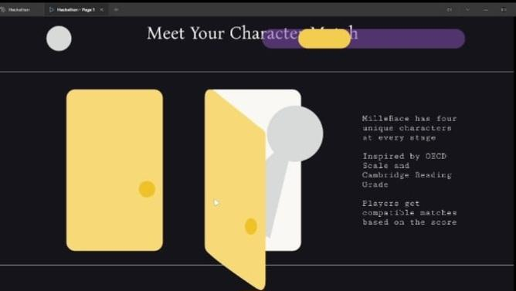
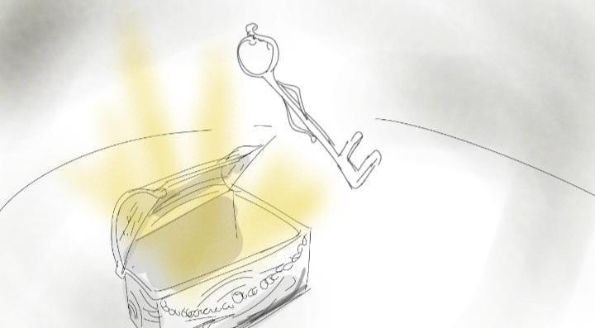
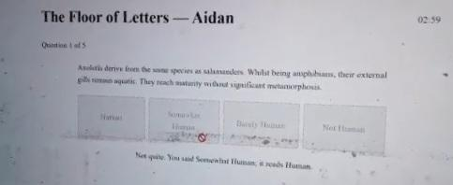
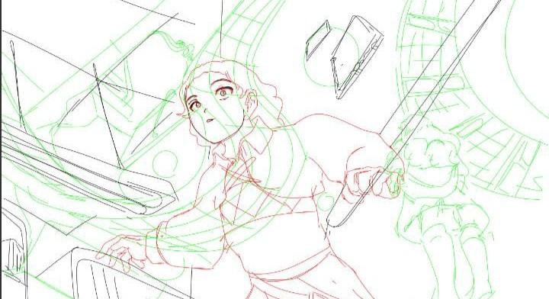

The table for timeline in Year 1:

TIMELINE | ACTIVITY | RESOURCES | OUTCOMES
JULY 2026 | - Team Recruitment  - Game Concepting (Scriptwriting, Animating, UI/UX Designing, Web Developing) | Team Members | 1 website product
AUGUST 2026 | - Initial Trials  - Pilot Testing | - Networks from formal and cram schools around East Kalimantan  - Networks from the public library  - Networks from Mulawarman University | 1. 10 primary-middle school students  2. 10 high school-varsity students
SEPTEMBER 2026 | - Feedback Integration | - 20 testimonies through A1-C1 levels | - 20 testimonies through A1-C1 levels
OCTOBER-DECEMBER 2026 | - Partnerships | - 3 prepared marketing strategies (User-Generated Content, School Tours, Door-to-Door)  - 3 prepared marketing personas (Adolescent, Young Adults and Advanced Readers) | - Sponsorship and Investments  - Brand Engagements  - KOL Specialists

3.2.2. Year 2
By Year 2, MilleRace will be ready for its full launch in the regional scaling. As Mulawarman University is based in East Kalimantan, the aim is to promote MilleRace to 5+ formal and cram schools. In this context, the approach methods are to implement MilleRace into extracurricular projects, create online challenges, and integrate in public libraries as a social movement. During this timeline, MilleRace will also need web-maintenance systems.

The table for timeline in Year 2:

TIMELINE | ACTIVITY | RESOURCES | OUTCOMES
JANUARY - APRIL 2027 | - Partnerships | - 5+ formal and cram schools across East Kalimantan  - 5+ public libraries across East Kalimantan | - Engagement Rate KPIs and Content Enhancement  - Extracurricular Projects  - Online Social Movements
MAY - AUGUST 2027 | - Full Launch  - Regional Reach | - Established users and other audiences  - 3+ Book Stores  - 4+ Reading and Writing Clubs  - 7+ Literary Festivals and Events | - Regional Publication  - 300+ users playing in MilleRace
AUGUST - SEPTEMBER 2027 | - Web Sustainability  - Feedback Integration | - Team Members  - Web Domain  - 300+ users through A1-C1 levels | - Website Enhancement  - Website Maintenance
OCTOBER - DECEMBER 2027 | - National Reach | - 10+ Education and Cultural Foundations  - 10+ Literary Communities | - National Publication  - 1.000+ users playing in MilleRace

3.2.3. Year 3
By Year 3, MilleRace will be ready for its full-on national reach before heading worldwide.. After establishing partnerships with more than 30 communities and social movements, and gaining enough funds for maintaining the website domain, MilleRace will be ready to be used by international users. The target is to create campaigns with UNESCO City of Literature and UNESCO Silk Road Magazines that are published around the world.

The table for timeline in Year 3:

TIMELINE | ACTIVITY | RESOURCES | OUTCOMES
JANUARY - APRIL 2028 | - Web Sustainability  - Feedback Integration | - Team Members  - Web Domain  - 1.000+ users through A1-C1 levels | - Website Enhancement  - Website Maintenance
MAY - AUGUST 2028 | - Global Partnerships | - UNESCO City of Literature  - UNESCO Silk Road Magazines | - 5.000+ Users in Social Campaigns designed by MilleRace
AUGUST - SEPTEMBER 2028 | - International Program Integration | - UNESCO City of Literature  - UNESCO Silk Road Magazines | - Improved curriculum
OCTOBER - DECEMBER 2028 | - Ongoing Monitoring | - Team Members  - Partners | - Continuous Improvements

3.3. Financial Projection
As seen from the timeline above, financial planning is crucial for the development of MilleRace. It involves sponsorships, partnerships, community investments, web maintenance and other aspects. The details for each will be stated in four different tables before coming into a total.

3.3.1. Financial Projection for Technology & Infrastructure

No | Item | Price | Quantity | Total
1 | Web Domain | $11.21/Year | 3 Years | $33.63
2 | Web Hosting/Cloud Server | $84/Year | 3 Years | $252
3 | Database/API Integration | $56/Year | 3 Years | $168
4 | Asset & Plugin Licenses | $44.85/Year | 3 Years | $134.55
 | YEARLY TOTAL |  |  | $196
 | 3-YEAR TOTAL |  |  | $785

3.3.2. Financial Projection for Content & Creative Production

No | Item | Price | Quantity | Total
1 | Character Design & Animation Assets | $112/Year | 3 Years | $336
2 | UI/UX Prototyping Tools & Web Assets | $28/Year | 3 Years | $84
3 | Post-Production | $56/Year | 3 Years | $168
 | YEARLY TOTAL |  |  | $196
 | 3-YEAR TOTAL |  |  | $588

3.3.3. Financial Projection for Pilot Testing & Community Engagement

No | Item | Price | Quantity | Total
1 | Beta Tester Incentives/Rewards | $84/Year | 3 Years | $252
2 | Offline Workshop & Public Library Engagement | $112/Year | 3 Years | $336
3 | Printable MIL Toolkits for Schools & Communities | $56/Year | 3 Years | $168
 | YEARLY TOTAL |  |  | $252
 | 3-YEAR TOTAL |  |  | $756

3.3.4. Financial Projection for Marketing & Operational

No | Item | Price | Quantity | Total
1 | Campaigns & User Acquisition | $84/Year | 3 Years | $252
2 | Team Operational | $56/Year | 3 Years | $168
3 | Contingency Fund | $56/Year | 3 Years | $168
 | YEARLY TOTAL |  |  | $196
 | 3-YEAR TOTAL |  |  | $588

3.3.5. Year-Round Total

No | Item | Price | Quantity | Total
1 | Technology & Infrastructure | $196 | 1 Year | $196
2 | Content & Creative Production | $196 | 1 Year | $252
3 | Pilot Testing & Community Engagement | $252 | 1 Year | $196
4 | Marketing & Operational | $196 | 1 Year | $196
 | GRAND TOTAL |  |  | $840

3.3.6. 3-Year Total

No | Item | Price | Quantity | Total
1 | Technology & Infrastructure | $196 | 3 Years | $588
2 | Content & Creative Production | $196 | 3 Years | $756
3 | Pilot Testing & Community Engagement | $252 | 3 Years | $588
4 | Marketing & Operational | $196 | 3 Years | $488
 | GRAND TOTAL |  |  | $2520

3.4. Feasiblity

